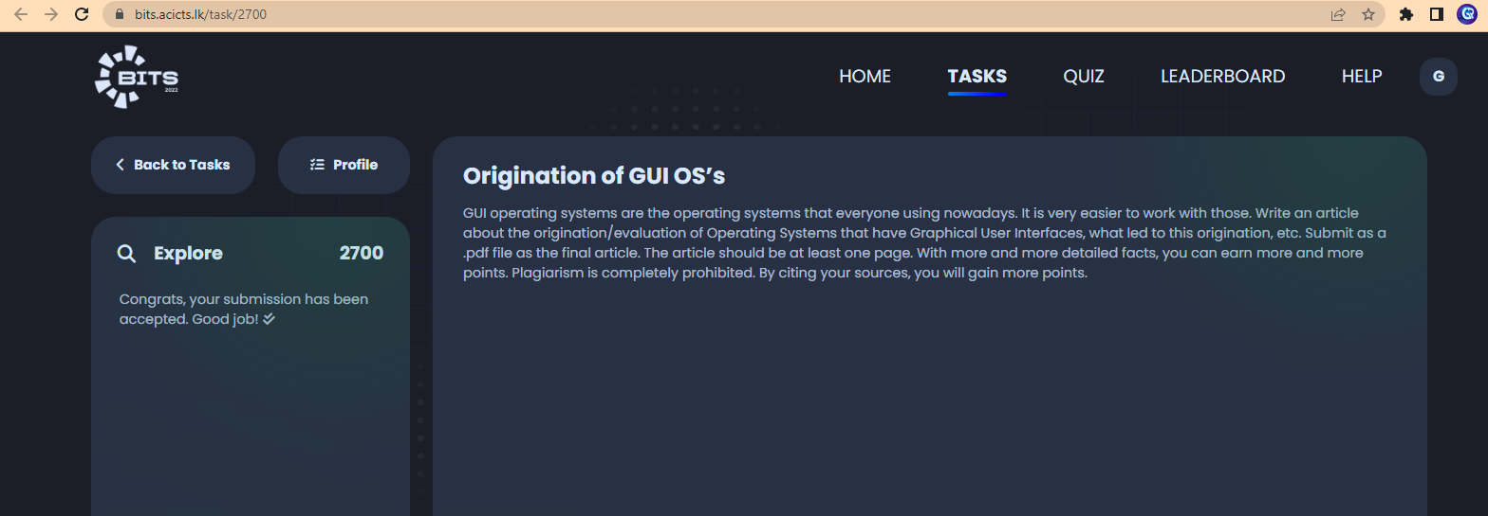On this task page, there should be bullets

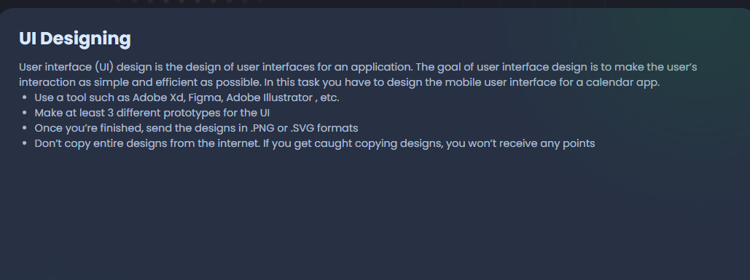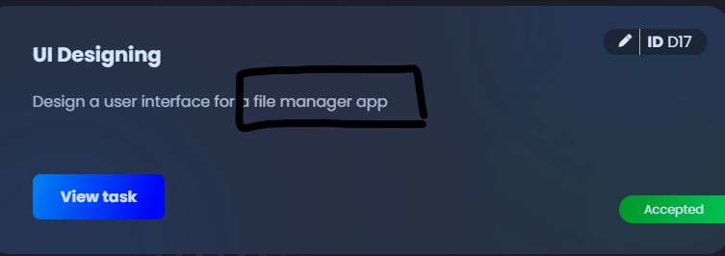This task said to make an interface for a file manager app. But inside the task, they said to make UI for a calendar app

In ToDo task spellings are not correct

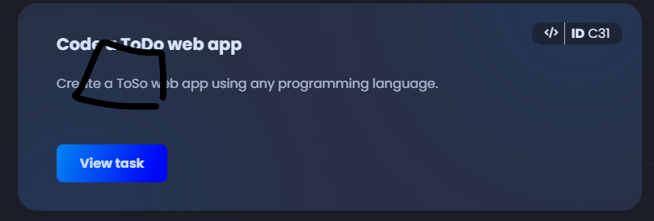

In all task descriptions “guidelines” should be “guidelines”

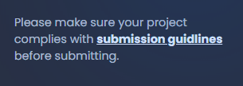

In this I think give should be changed to gives because creativity is a singular thing:

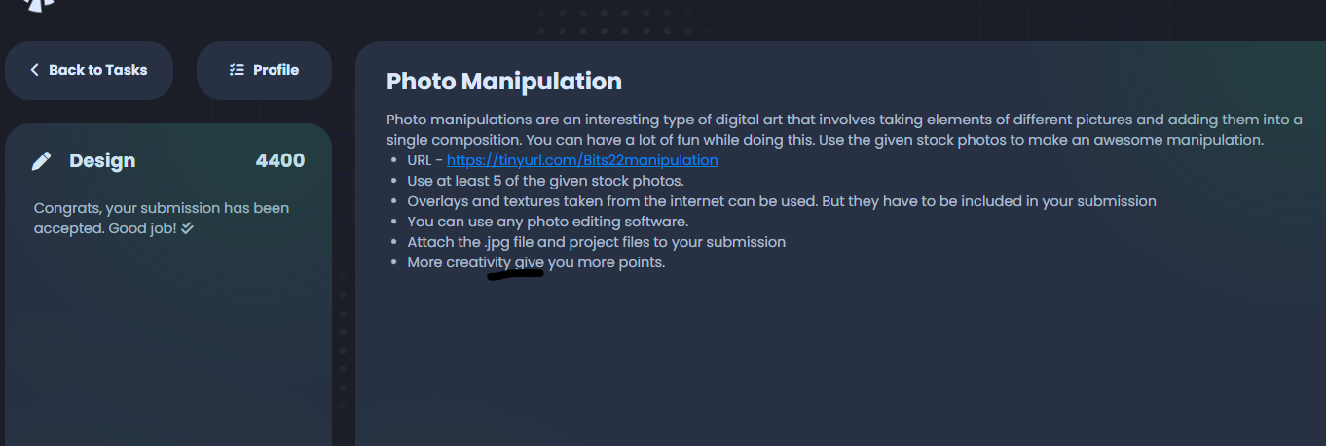

The following are some grammatical mistakes (More fancy – Fancier | from - in

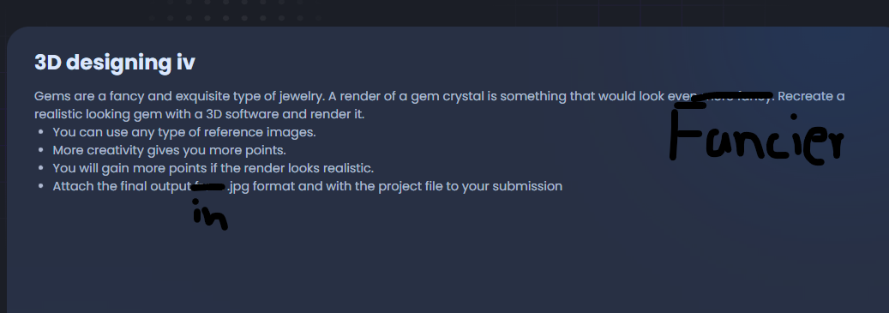

In this task there is a coding problem (short description should be remove I think)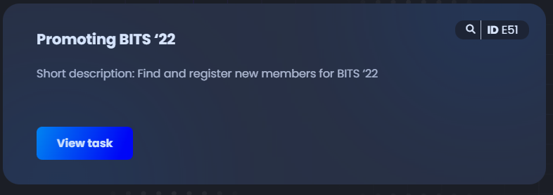

In this also some grammatical mistakes (there should be a before lost & has should remove and put have)

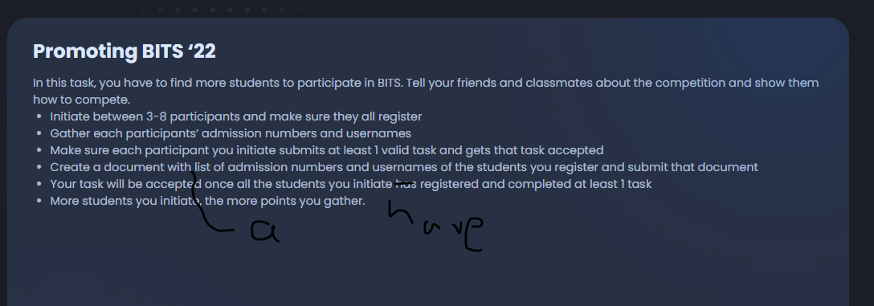

In the following task, there is a typo (blogpost should be two words) why only 2 sentences were bold?

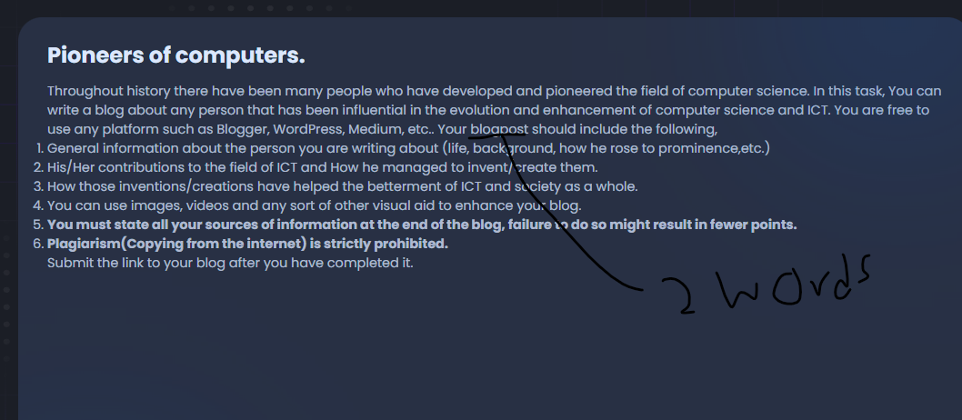

In this, there is a small mistake (explains should be explanations)

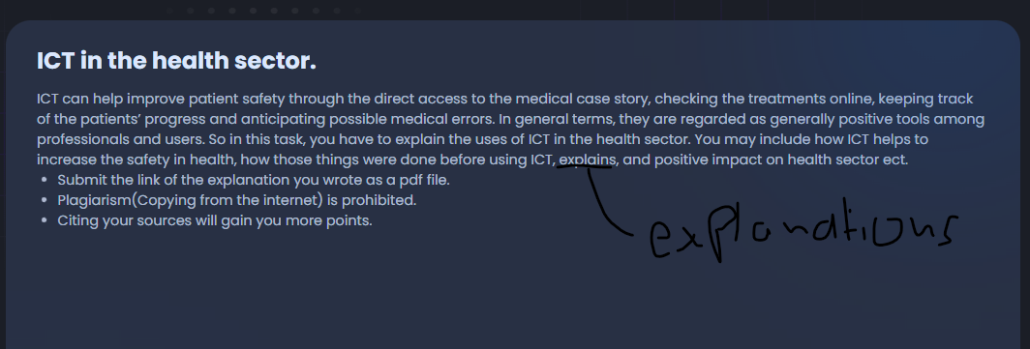those are mistakes I mentioned!